**Praktikum 3 Sistem Basis Data 2023**

**NRP / Nama :** 5025221191/Ahmad Fatih Ramadhani **Kelas :** G

**RDBMS :** MySQL

**Link SQL : https://drive.google.com/file/d/1sMX96WbNH2n1w83wdCTjUlaQknJUlmOY/view?usp=sharing**

**Kode Asdos :** SBDG01

**Sesi : PRAKTIKUM 3**

**Nomor 1**

Sintaks:

**SELECT** idBarang, namaBarang, Stock - terbeli **AS** nilai_stock_terkini

**FROM**

(**SELECT** p.id **AS** idBarang, p.**name** **AS** namaBarang, **COUNT**(pc.quantity) **AS** terbeli, p.stock **AS** Stock, pc.product_id

**FROM** products p

**JOIN** product_carts pc **ON** p.id = pc.product_id

**JOIN** carts c **ON** pc.cart_id = c.id

**WHERE** c.`status` = 'checkout'

**GROUP** **BY**

pc.product_id) hasil

**GROUP** **BY**

idBarang,namaBarang

Hasil:

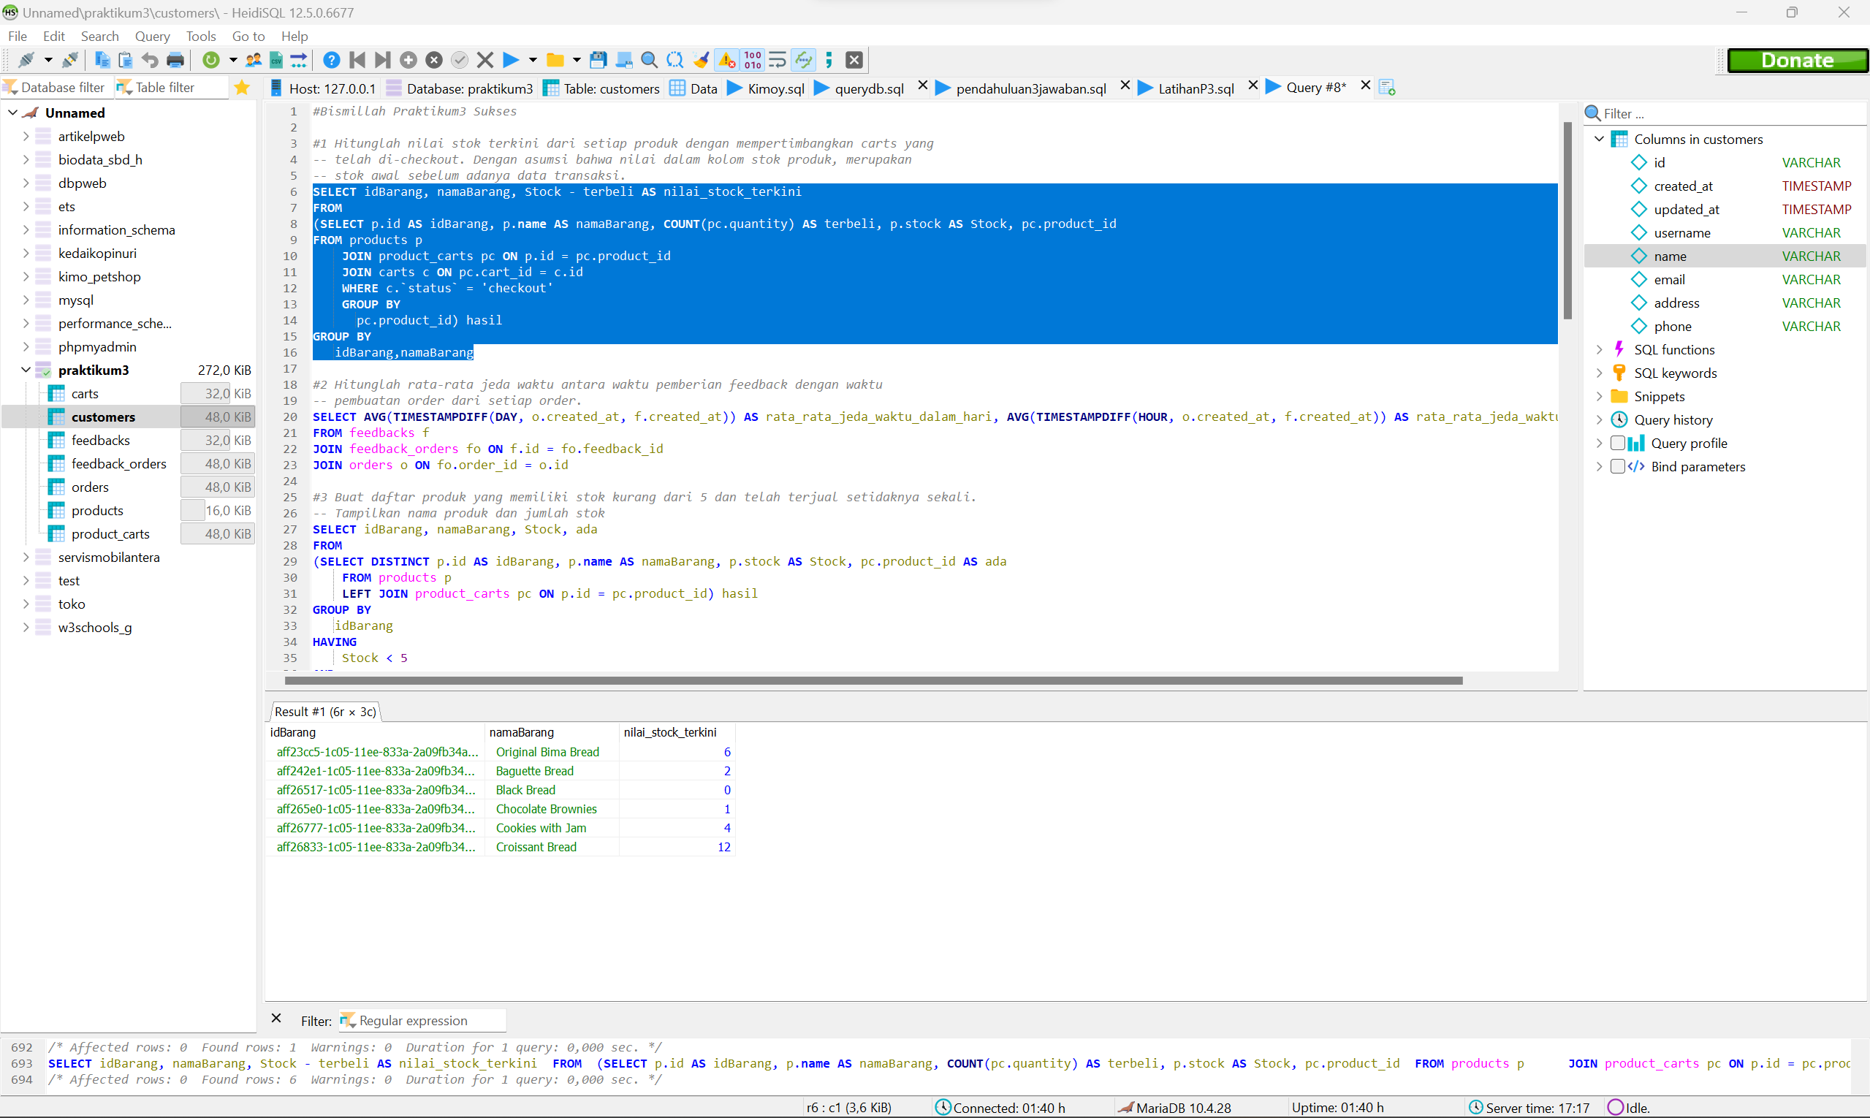

**Nomor 2**

Sintaks:

**SELECT** **AVG**(**TIMESTAMPDIFF**(**DAY**, o.created_at, f.created_at)) **AS** rata_rata_jeda_waktu_dalam_hari, **AVG**(**TIMESTAMPDIFF**(**HOUR**, o.created_at, f.created_at)) **AS** rata_rata_jeda_waktu_dalam_jam

**FROM** feedbacks f

**JOIN** feedback_orders fo **ON** f.id = fo.feedback_id

**JOIN** orders o **ON** fo.order_id = o.id

Hasil:

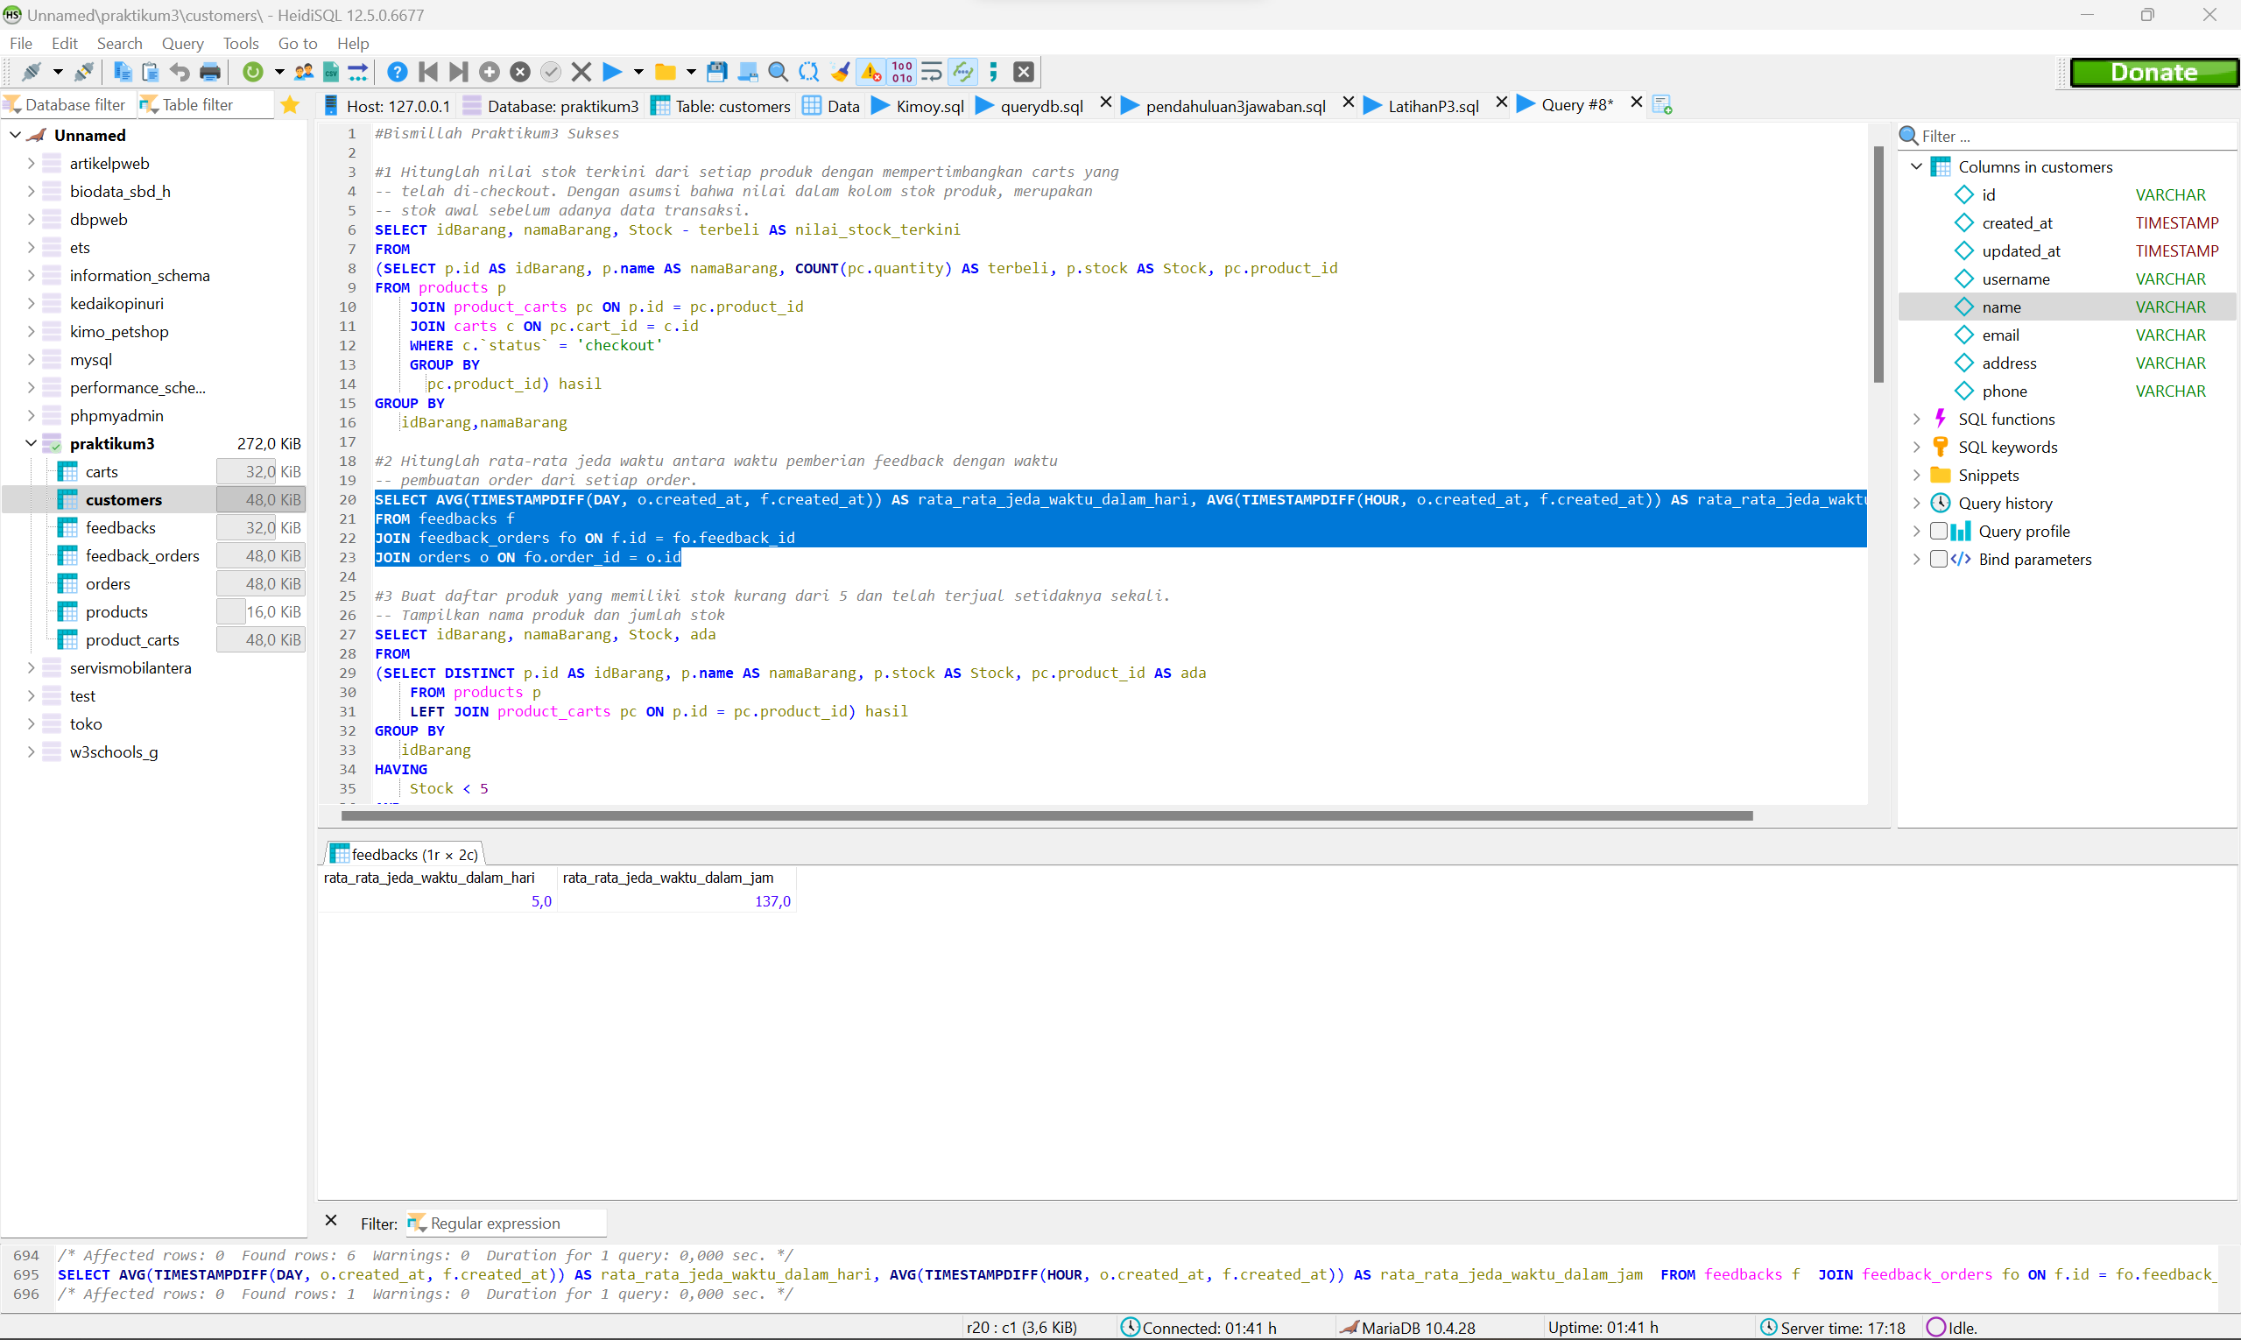

**Nomor 3**

Sintaks:

**SELECT** idBarang, namaBarang, Stock, ada

**FROM**

(**SELECT** **DISTINCT** p.id **AS** idBarang, p.**name** **AS** namaBarang, p.stock **AS** Stock, pc.product_id **AS** ada

**FROM** products p

**LEFT** **JOIN** product_carts pc **ON** p.id = pc.product_id) hasil

**GROUP** **BY**

idBarang

**HAVING**

Stock < 5

**AND**

idBarang **IN**(ada)

Hasil:

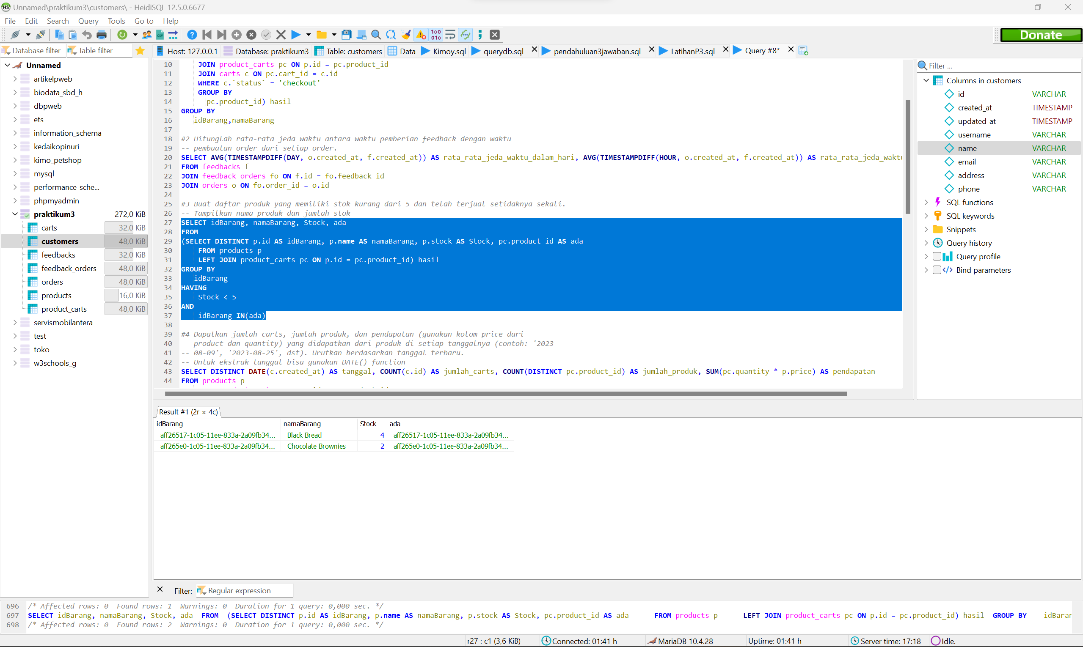

**Nomor 4**

Sintaks:

**SELECT** **DISTINCT** **DATE**(c.created_at) **AS** tanggal, **COUNT**(c.id) **AS** jumlah_carts, **COUNT**(**DISTINCT** pc.product_id) **AS** jumlah_produk, **SUM**(pc.quantity * p.price) **AS** pendapatan

**FROM** products p

**JOIN** product_carts pc **ON** p.id = pc.product_id

**JOIN** carts c **ON** pc.cart_id = c.id

**GROUP** **BY**

tanggal

Hasil:

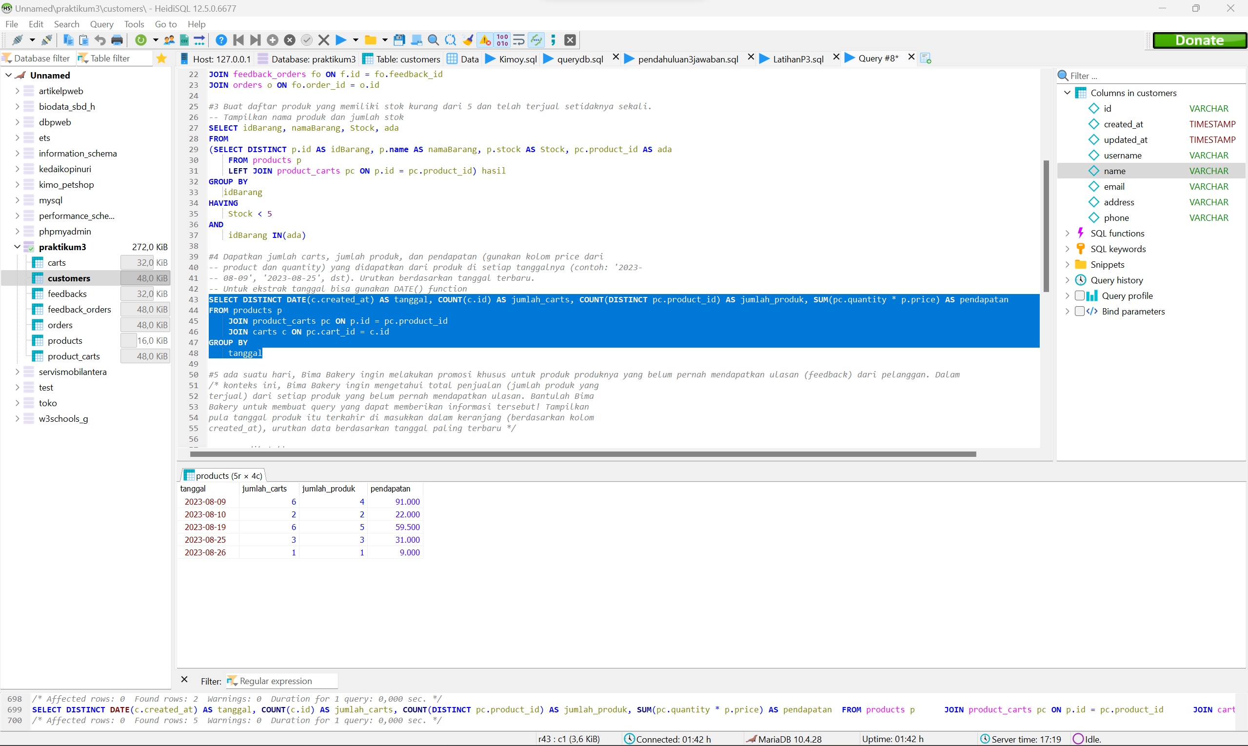

**Nomor 5**

Sintaks:

**SELECT** *

**FROM** products p

**LEFT** **JOIN**

(**SELECT** **DISTINCT** p.id **AS** sudah_direview

**FROM** products p

**JOIN** product_carts pc **ON** p.id = pc.product_id

**JOIN** orders o **ON** pc.cart_id = o.cart_id

**JOIN** feedback_orders fo **ON** o.id = fo.order_id

**JOIN** feedbacks f **ON** fo.feedback_id = f.id

**GROUP** **BY** p.id) produk_direview **ON** p.id = sudah_direview

**GROUP** **BY**

p.id

Hasil:

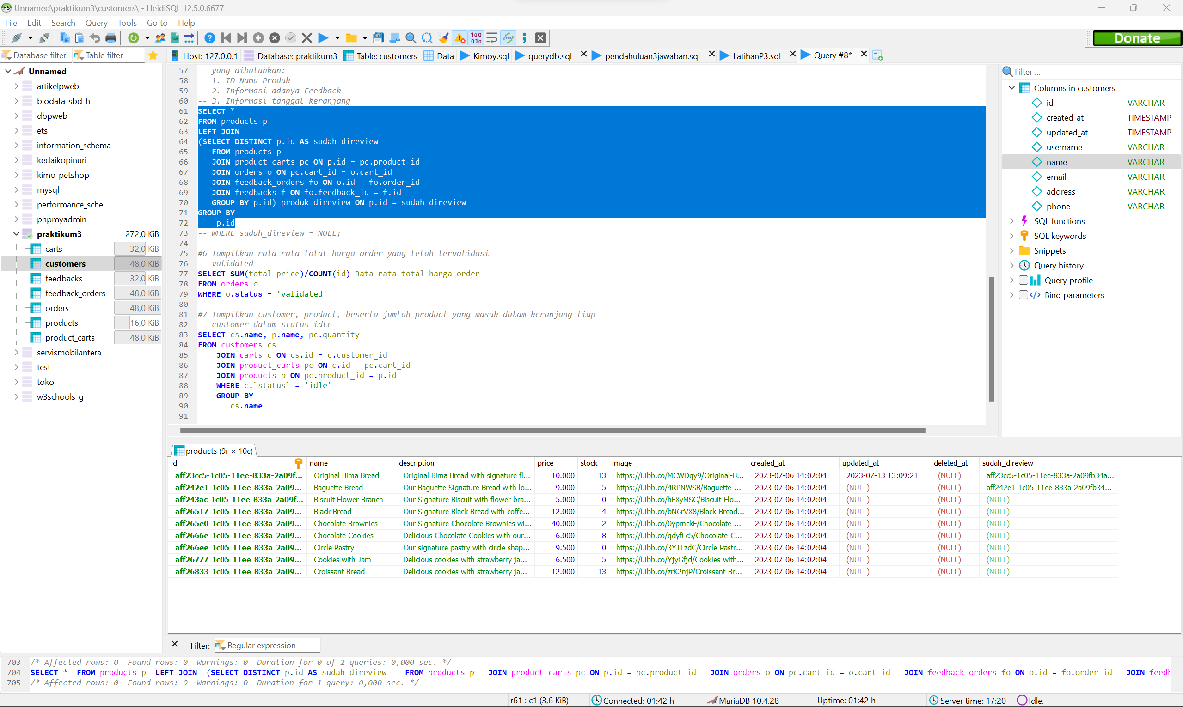

**Nomor 6**

Sintaks:

**SELECT** **SUM**(total_price)/**COUNT**(id) Rata_rata_total_harga_order

**FROM** orders o

**WHERE** o.**status** = 'validated'

Hasil:

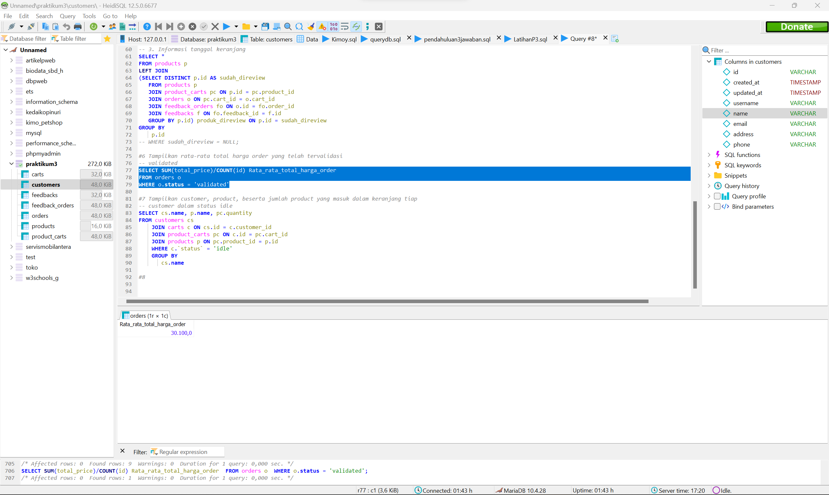

**Nomor 7**

Sintaks:

**SELECT** cs.**name**, p.**name**, pc.quantity

**FROM** customers cs

**JOIN** carts c **ON** cs.id = c.customer_id

**JOIN** product_carts pc **ON** c.id = pc.cart_id

**JOIN** products p **ON** pc.product_id = p.id

**WHERE** c.`status` = 'idle'

**GROUP** **BY**

cs.**name**

Hasil:

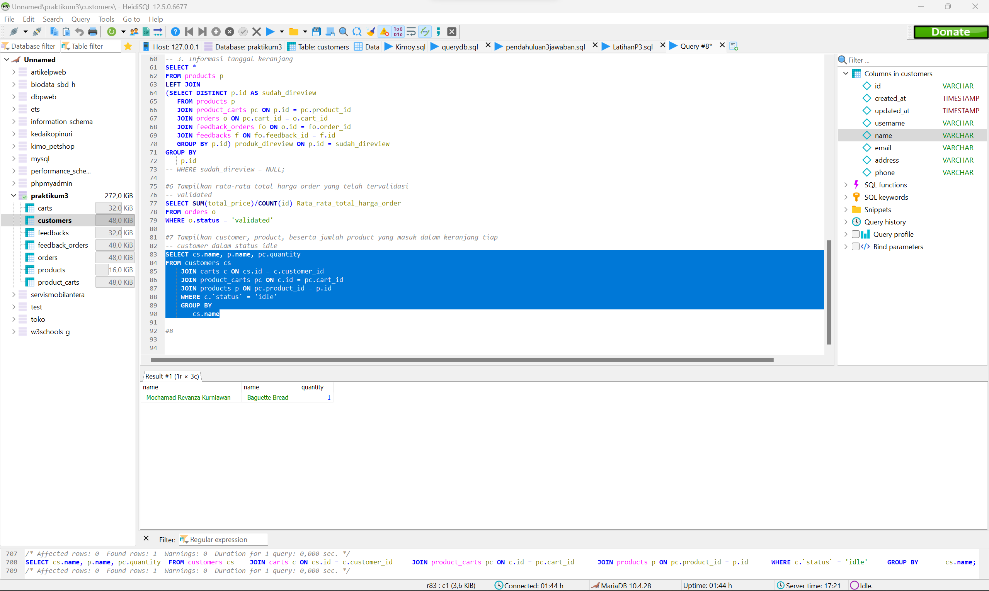

**Nomor 8**

Sintaks:

Hasil:

**Nomor 9**

Sintaks:

Hasil:

**Nomor 10**

Sintaks:

Hasil: